- Creating a user with name Techie and providing sudo access to it.
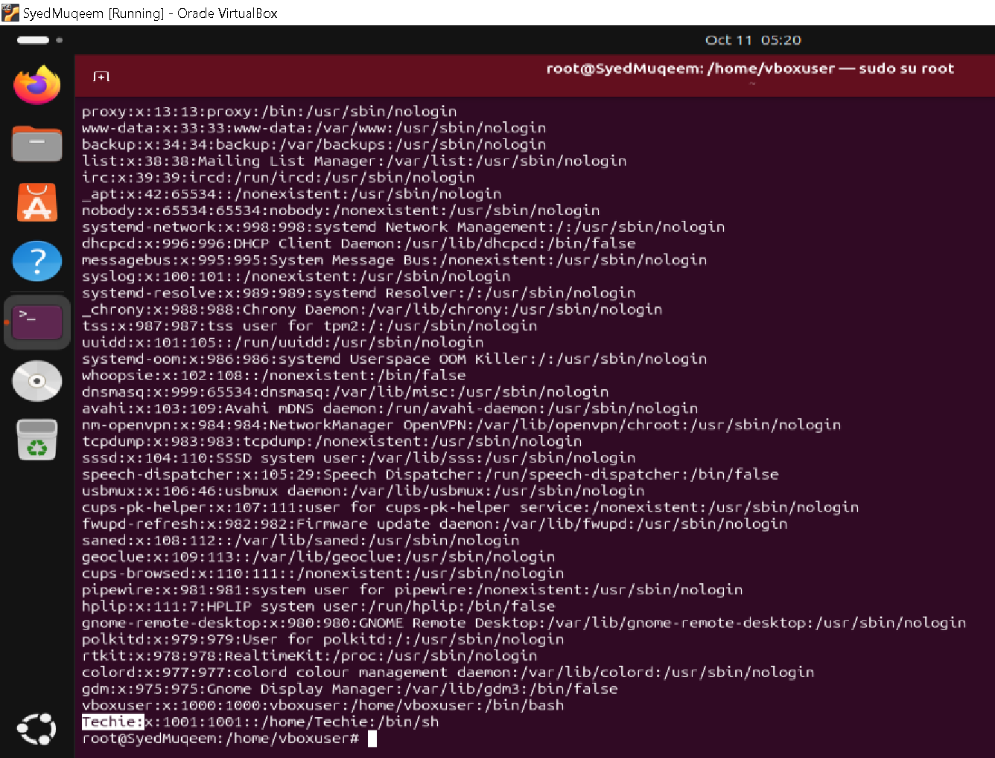

Provided special privilages to user “Techie”
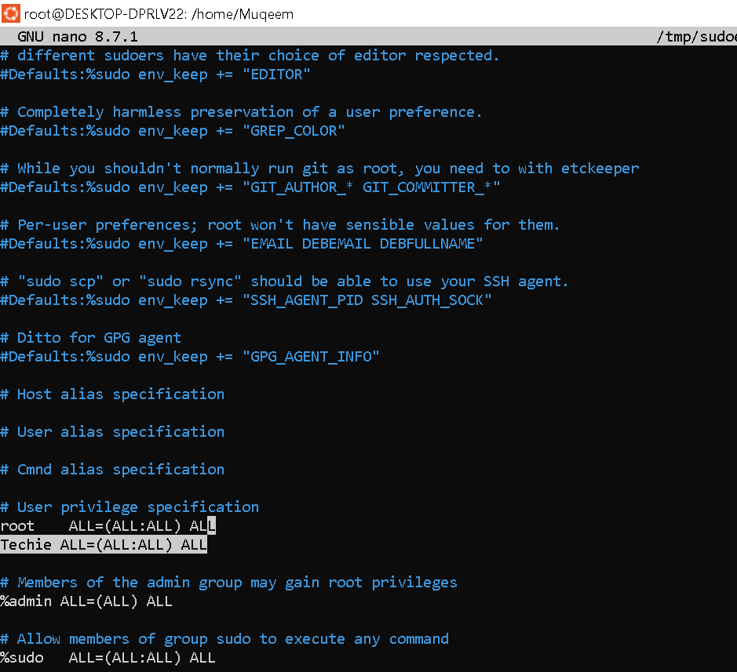90909090909090090

- Navigating to the home directory
Using command : cd ~
And creating a new directory with name “Thchie”

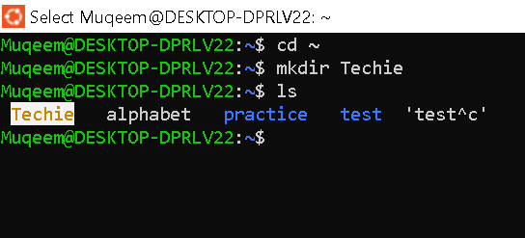

- List the content of directory
Using command : ls
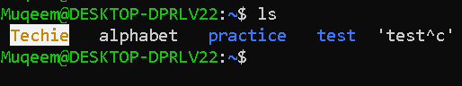

- Changed the current directory
Using the command : cd practice/
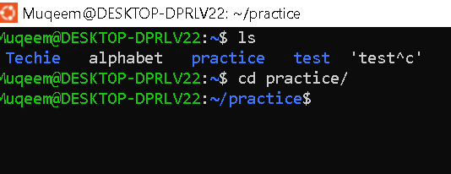

- Created a new empty file
Using the command: touch exmt

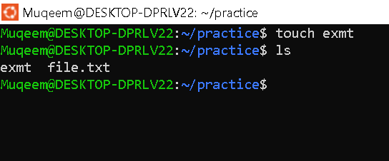

- Viewing the content of the
Using the command: ls
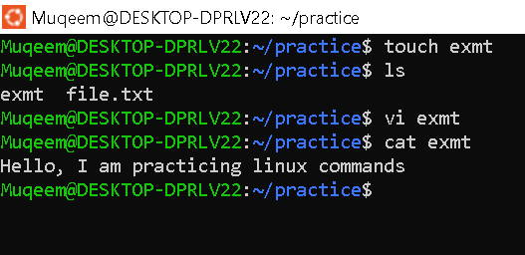

- Copied a file to another location
Using the command: cp exmt ~/practice/ Techie/

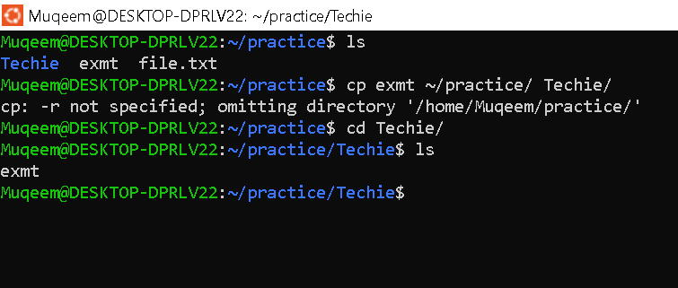

- Moving a file to another location
Using the command : mv alphabet ~/practice/

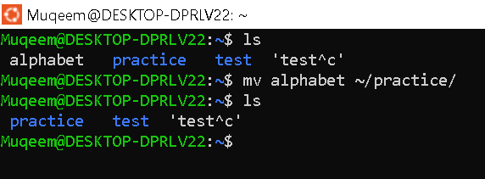

- Renamed a file using the command
: mv exmt Empty

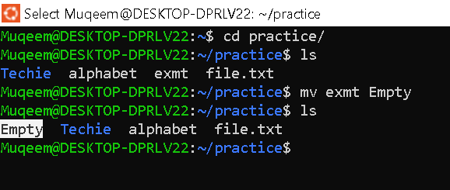

- Deleted a file using the command
: rm Empty

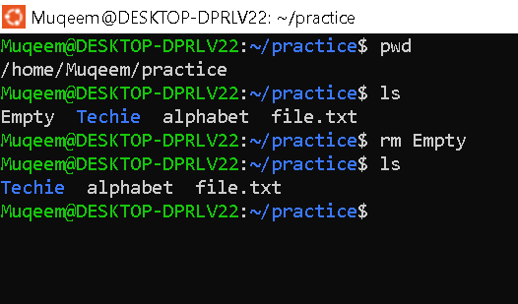

- Granting and revoking permissions to file using the command
: chmod

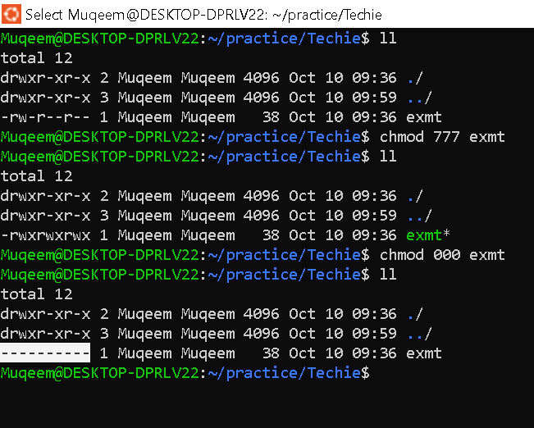

- View current date and time using the command
: date

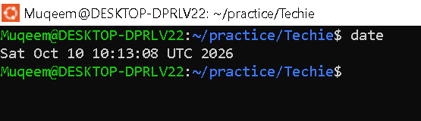

- Checked the system uptime using the command
: uptime
If stuck in the command u (ctrl+q) to continue
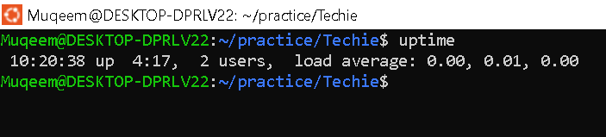

- View the running processes.

To view the running process we use the command
: ps PID = Process Id

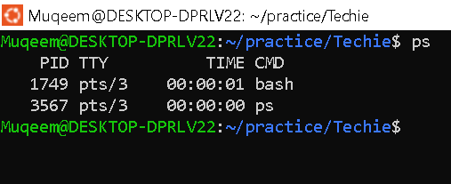

- View the running processes using the command
: Ps -ef
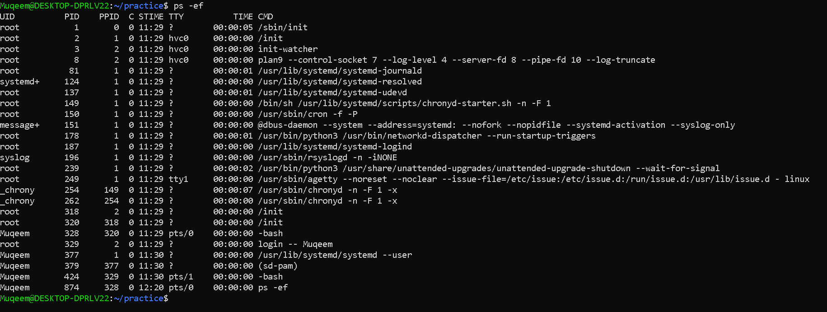

- Kill a running process using the command

Note: to execute kill command create a dummy process running in background ( (sleep 1000 & )
: kill “Process Id” ex. Kill 769
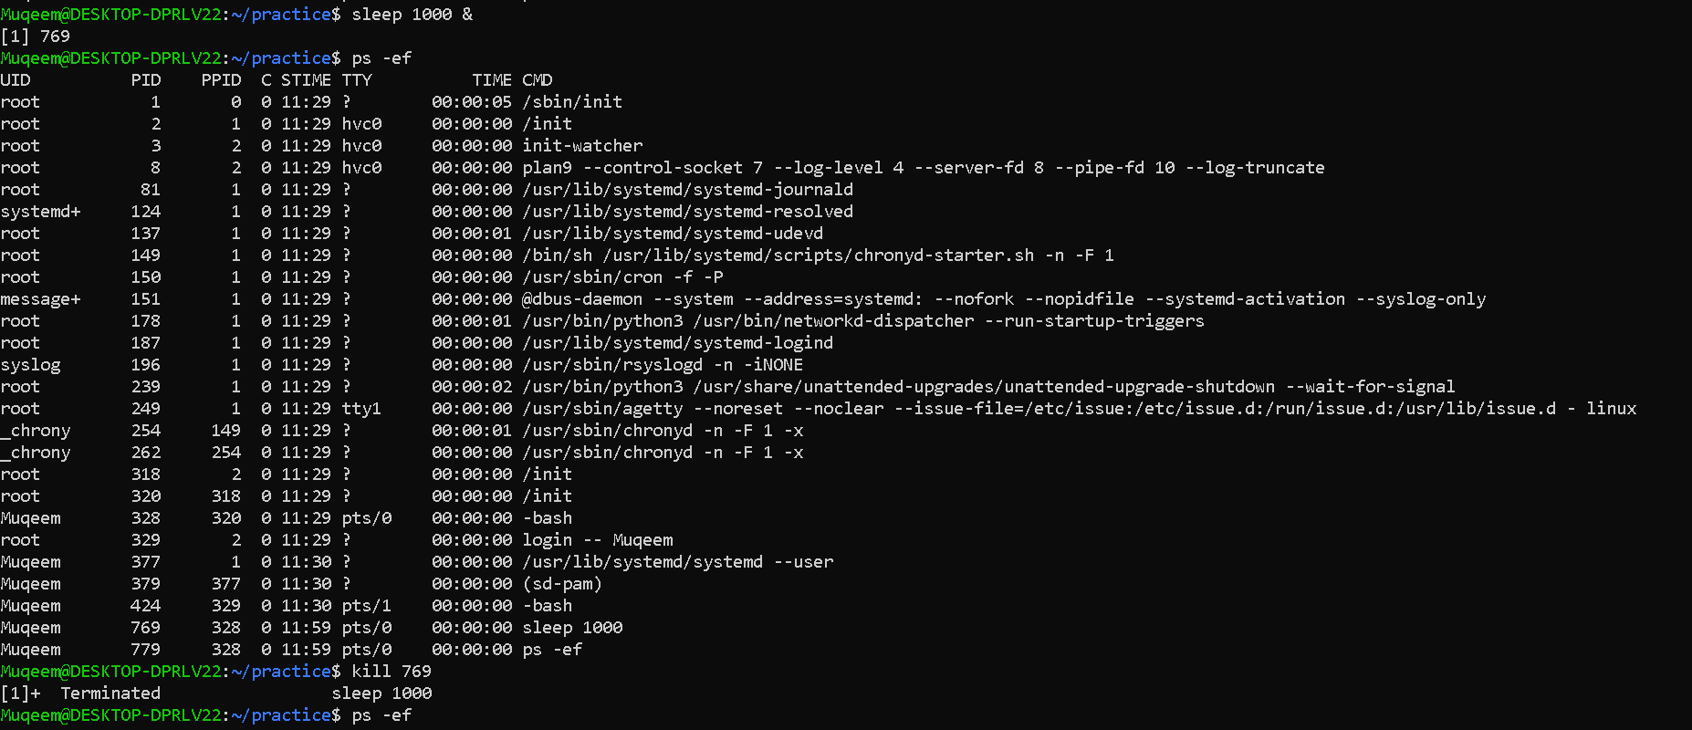

- Install a package using the package manager command
: apt install git Note: if not work use : sudo apt install git
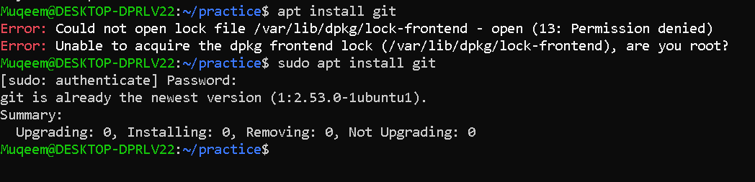

- Update the system packages using the command
: sudo apt upgrade

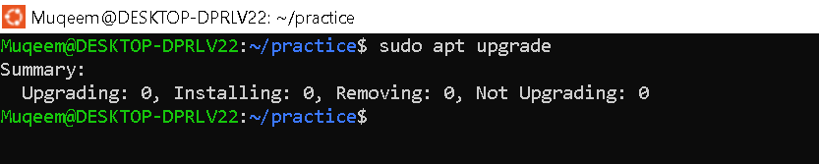

- Create a symbolic link using the command
: ln -s file1 existing new file (ln -s example Muqeem)

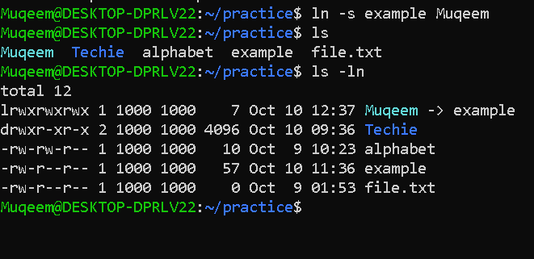

- Finding a file using the command
: find . -name file name

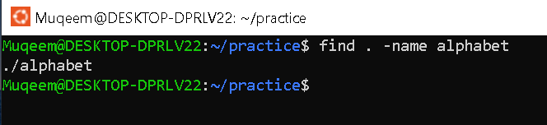

- Compressing and decompressing a file using tar command
: tar cvf techie.tar test_tar (cvf= create verbose file)

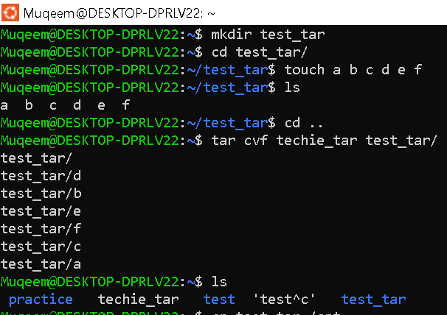

Decompressing a file using tar command
: tar xvf techie.tar (xvf = xtract verbose file)

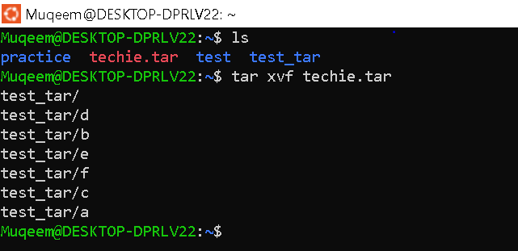

- Monitoring system resources using top command
: top
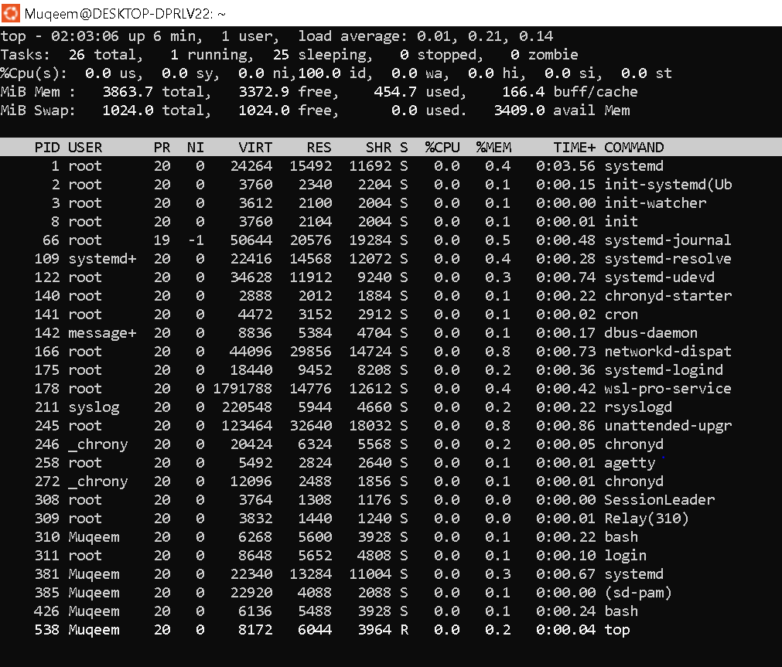

- Create and manage user groups.
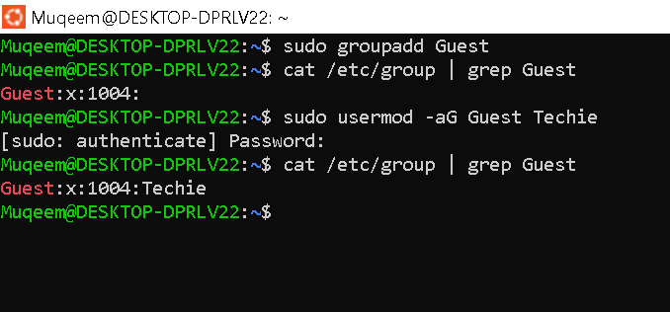

- Set up SSH password less authentication.
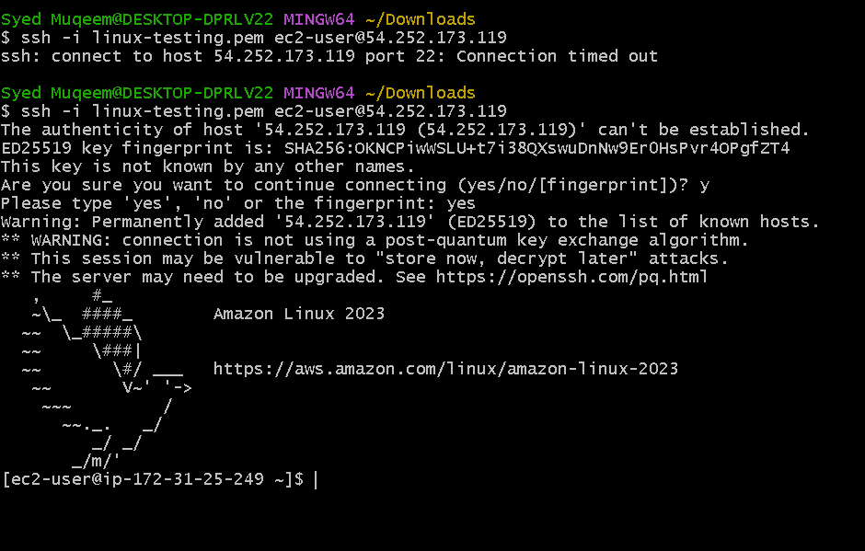
- Monitor log files using tail or grep. 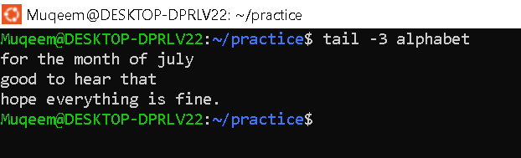
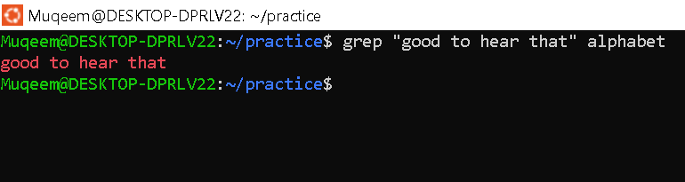

- Set up a web server (nginx)
Using the command : “sudo apt install nginx”
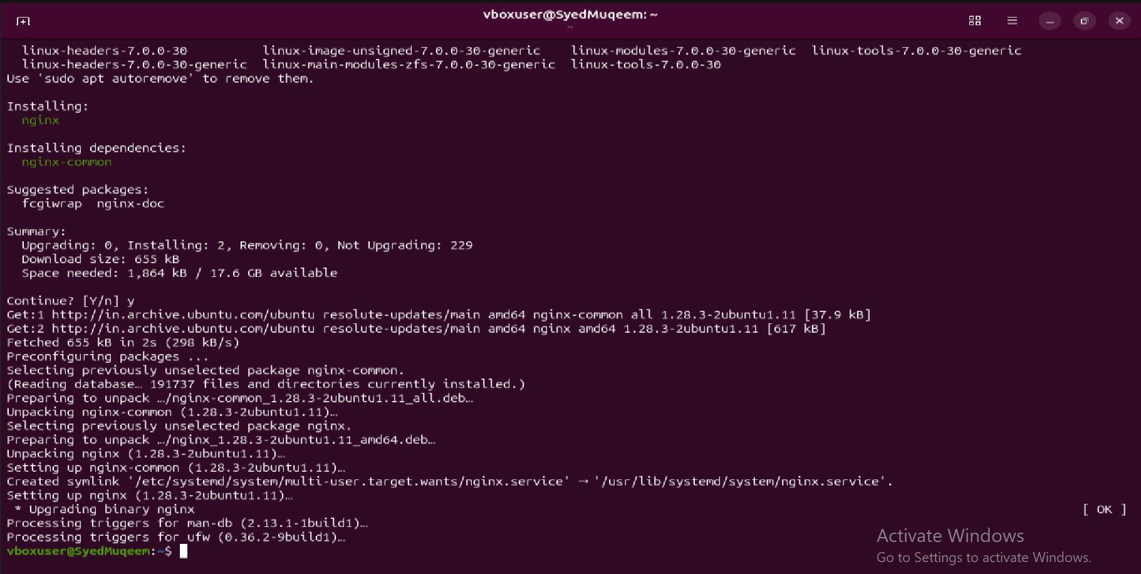
Status Checked using command : ”sudo systemctl status nginx”
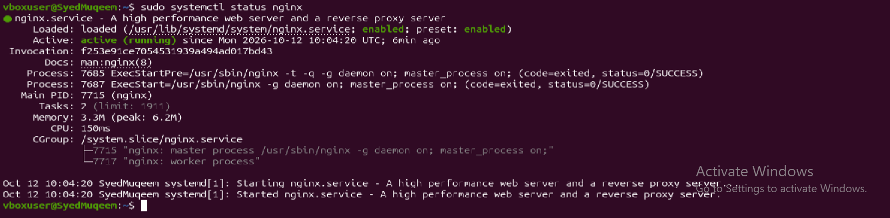

- Configured and secure mysql database.
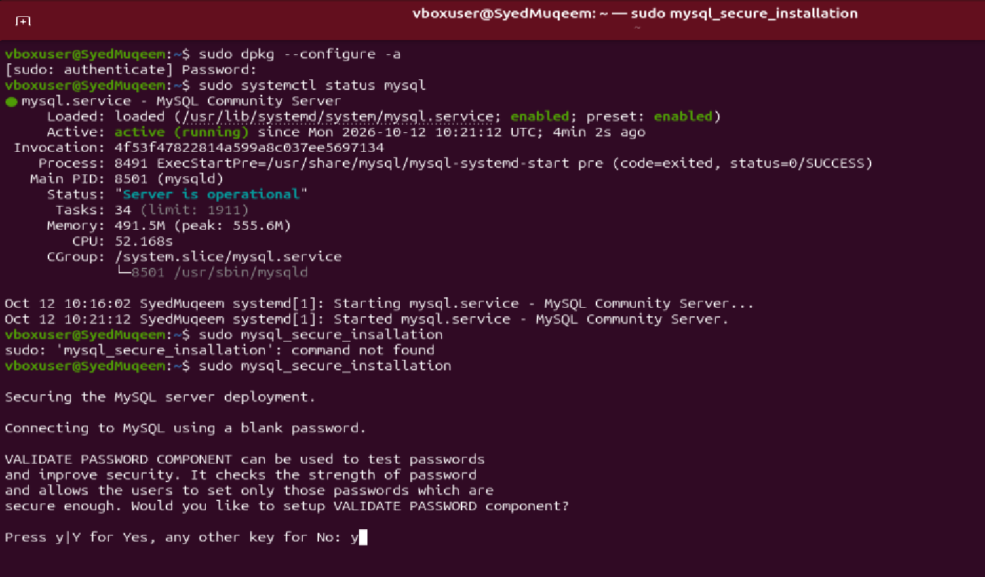
- Set up an Application server eg. Apache.
Using the commands
:(sudo update, sudo upgrade, sudo apt install tomcat10)
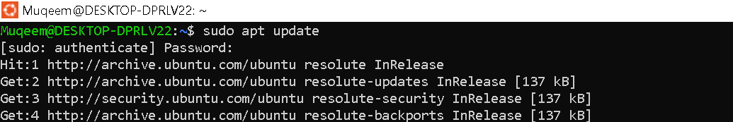

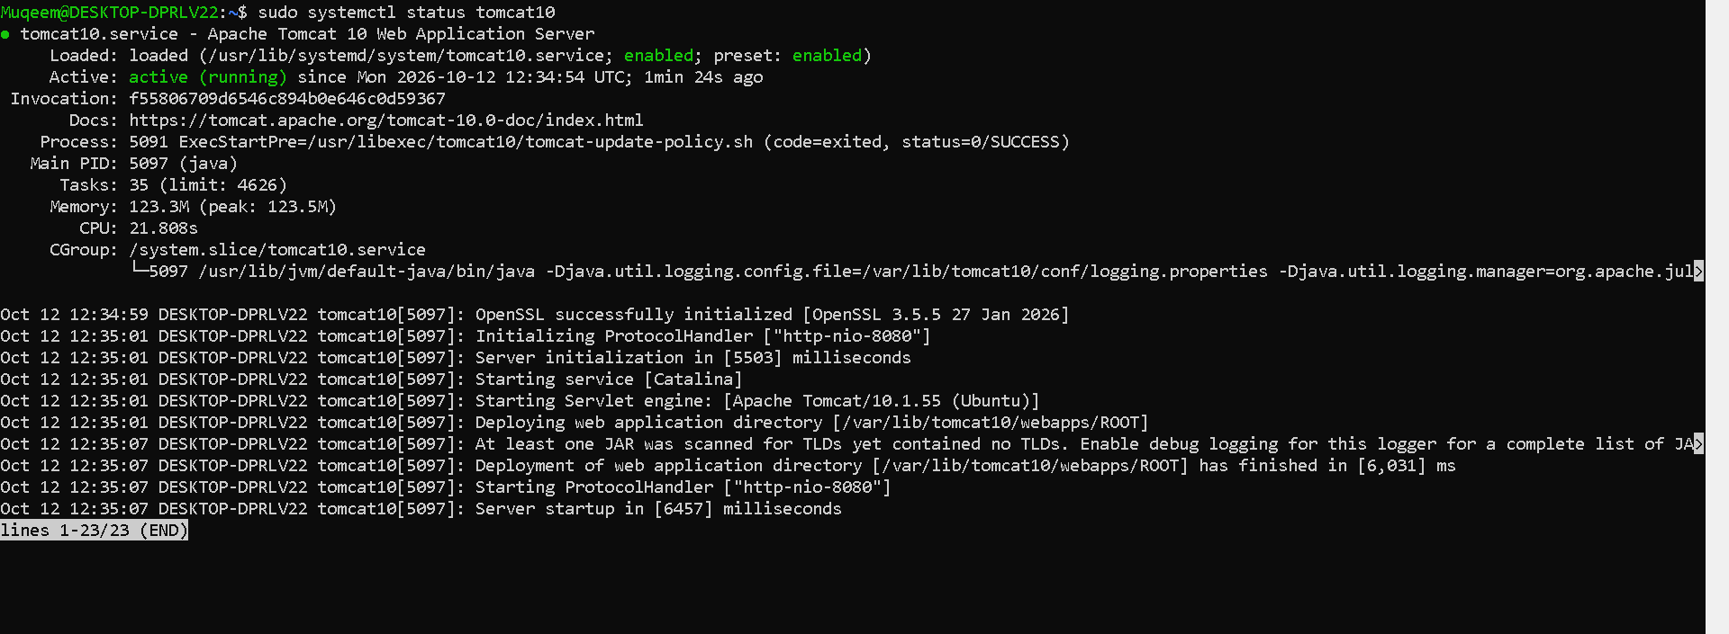

- Create a service file for apache tomcat (should execute by using systemctl command).
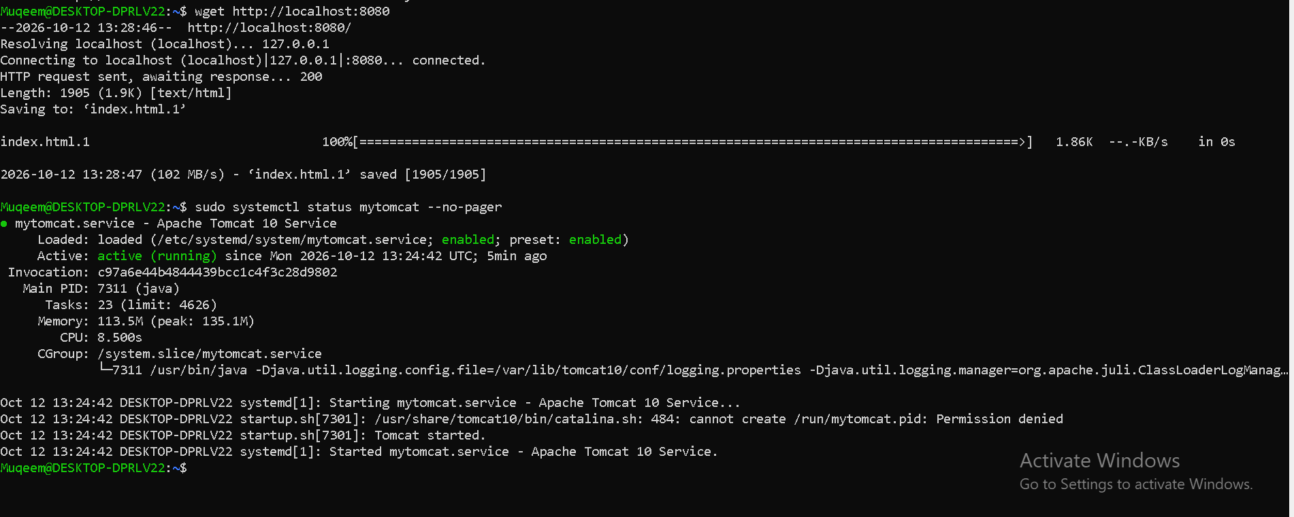
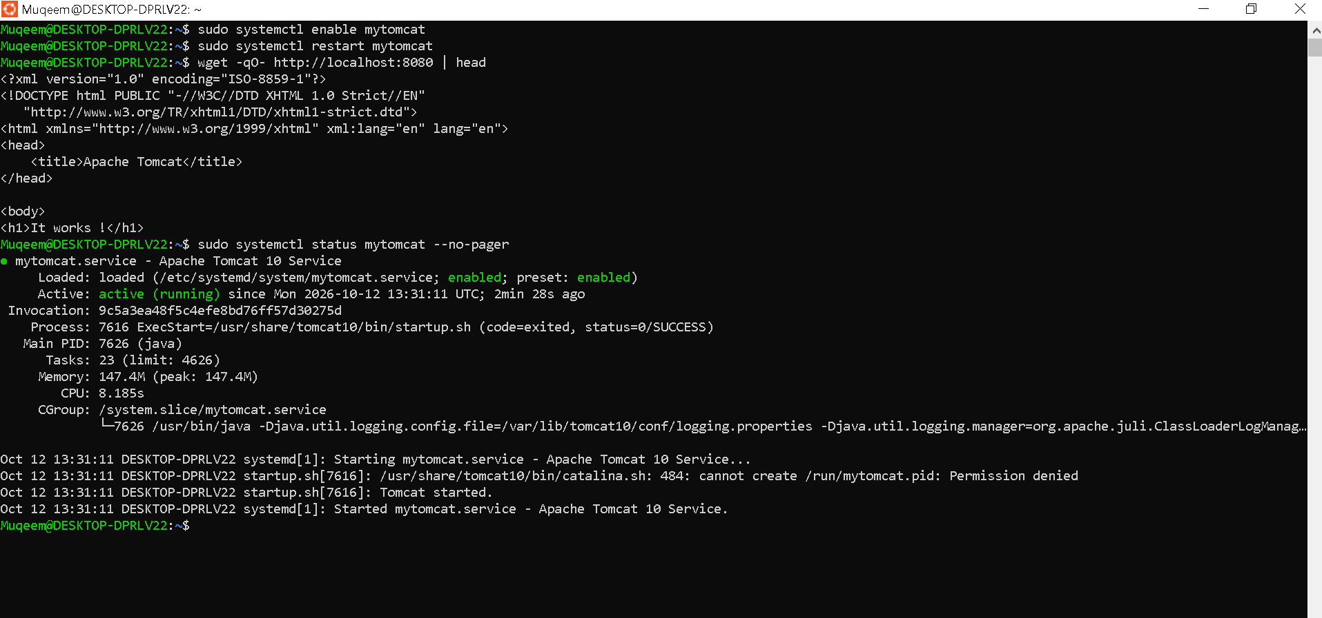

- Print specific columns from a delimited file.
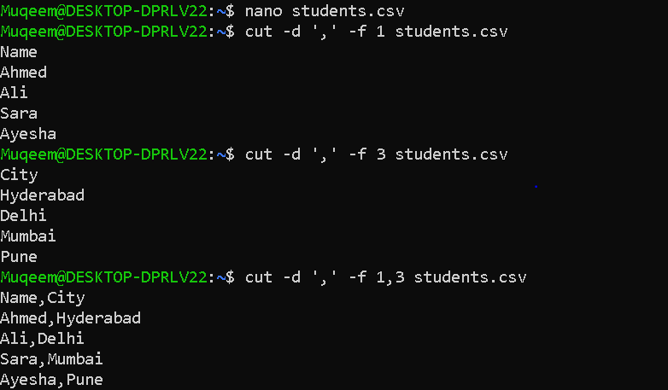

- Calculate and print the average sum of or other static of a column.
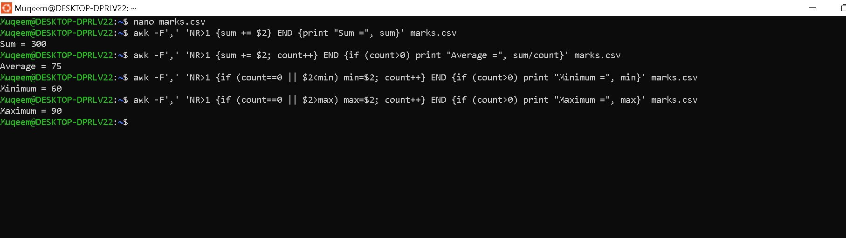

- filter and print lines based on a specific pattern or condition
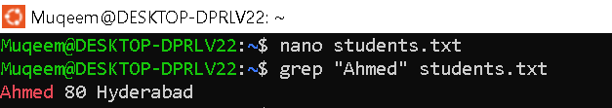
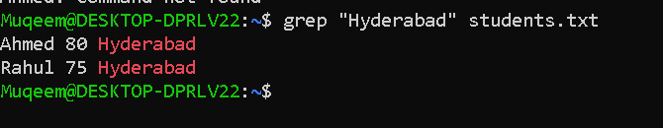
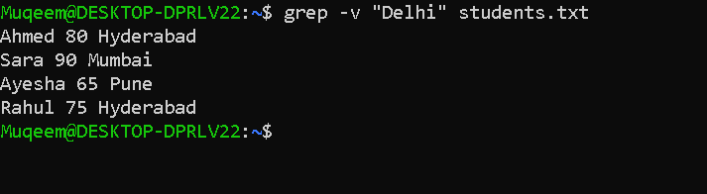

- perform string manipulation, such as extracting substrings or changing case.
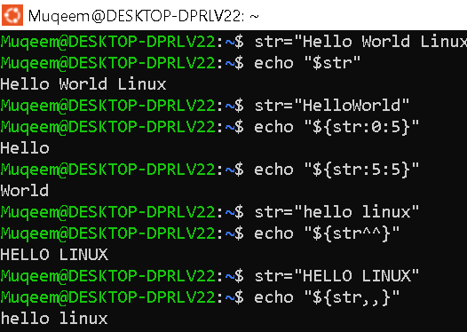

- Count the occurrence of a specific patter in a file.
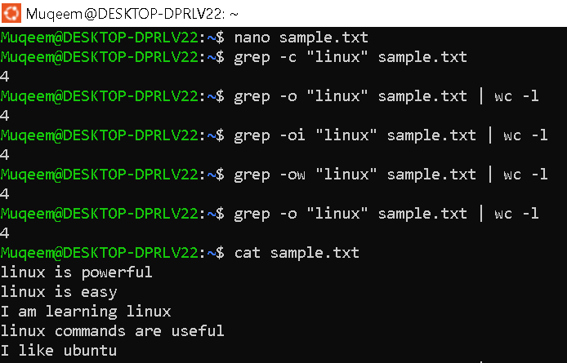

- Sort lines based on a specific field or column.
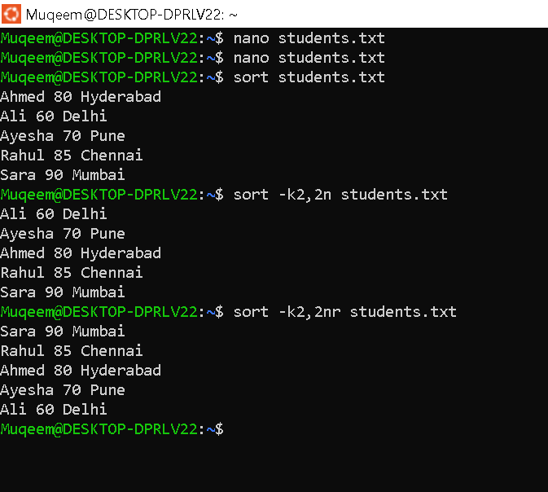
36.Merge multiple files based on a common field or column.
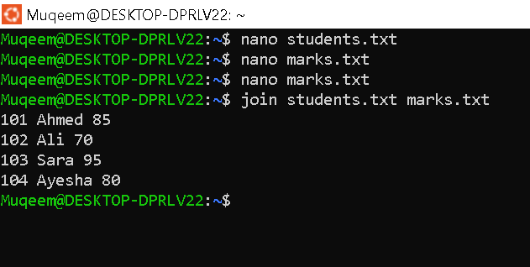
- Substitute text in a file using search and replace .
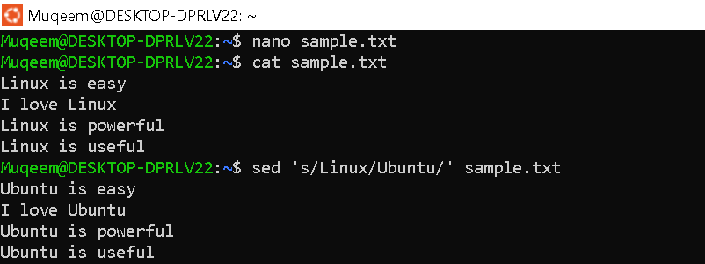

38.Delete Specific lines based on a pattern or line number.
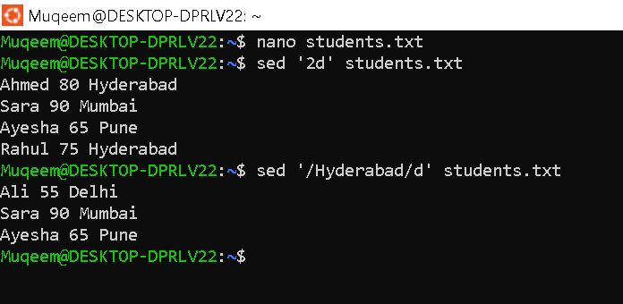
39. Append or insert text before or after a specific pattern or line.
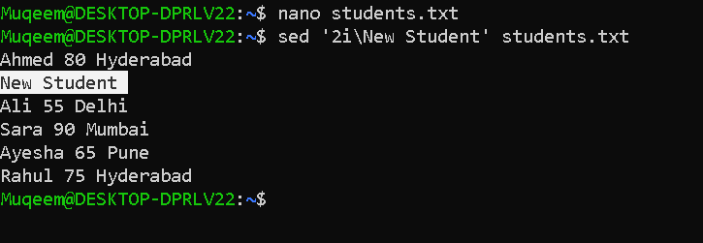
40. Print only specific lines from a file.
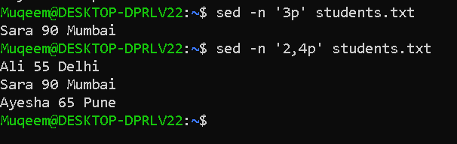
41. Copy file from linux to windows machine.
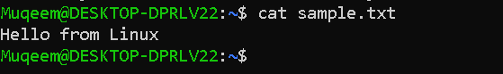

42. Five use cases for AWK and 5 use cases for sed.
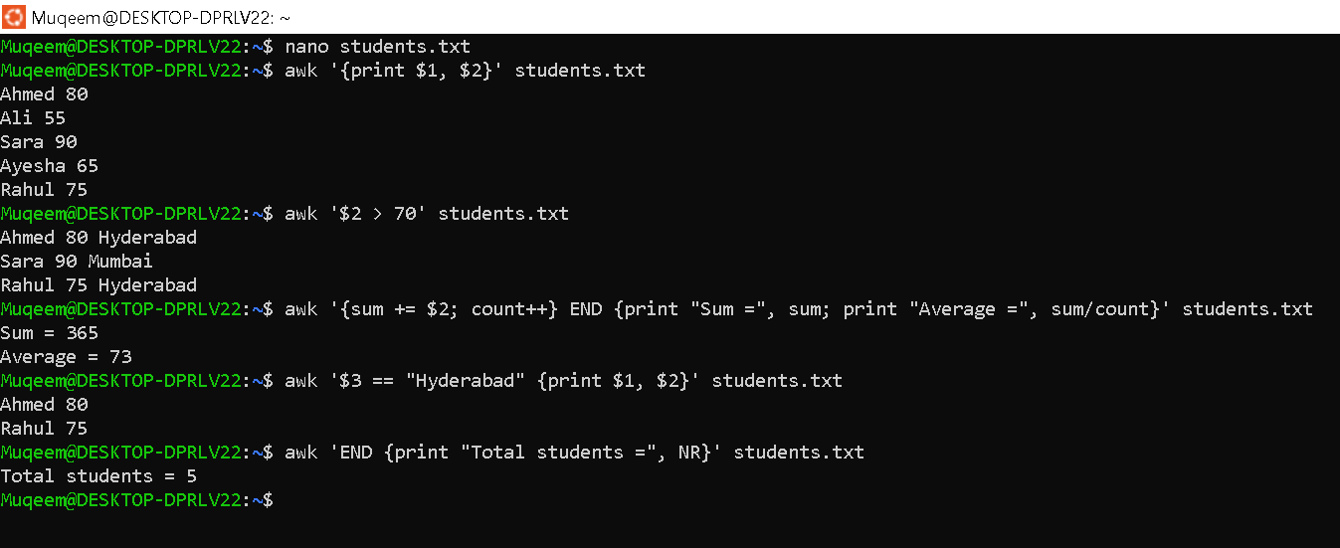

42. Five use cases for sed.


